**Project Design Phase-II**

**Data Flow Diagram & User Stories**

|  |  |
| --- | --- |
| Date | 31 January 2025 |
| Team ID | LTVIP2025TMID51556 |
| Project Name | Visualizing Housing Market Trends: An Analysis of Sales |
| Maximum Marks | 4 Marks |

**Data Flow Diagrams:**

A Data Flow Diagram (DFD) is a traditional visual representation of the information flows within a system. A neat and clear DFD can depict the right amount of the system requirement graphically. It shows how data enters and leaves the system, what changes the information, and where data is stored.

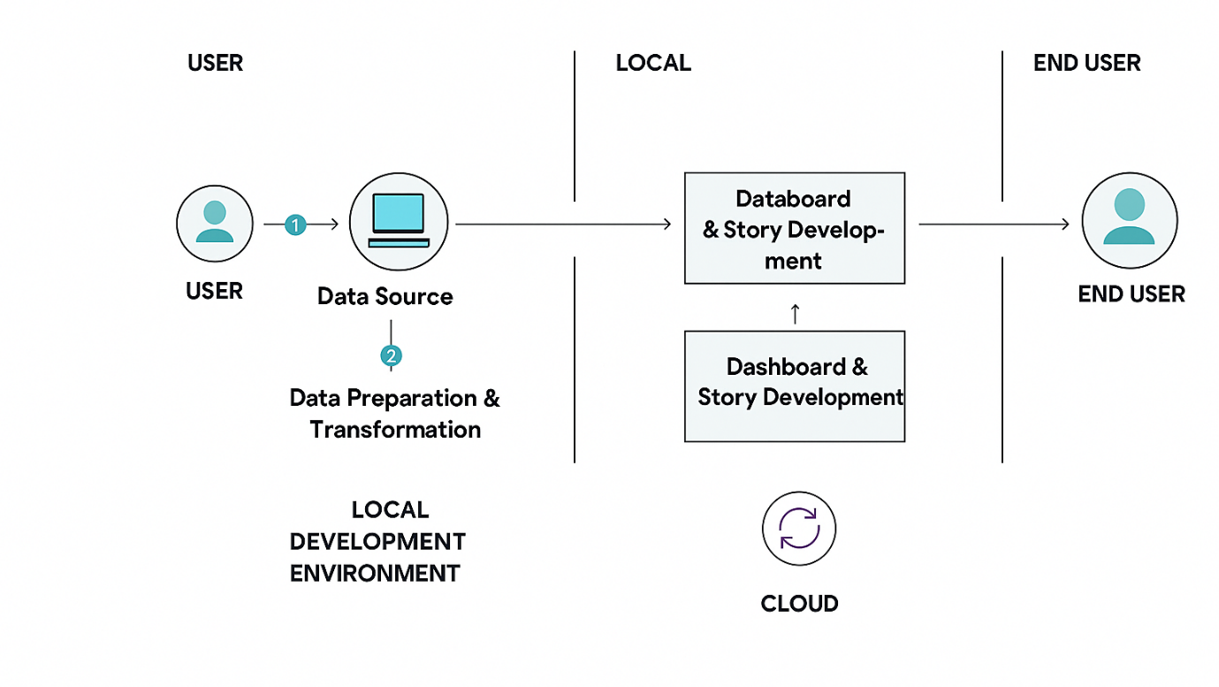

**User Stories**

|  |  |  |  |  |  |  |
| --- | --- | --- | --- | --- | --- | --- |
| User Type | Functional Requirement  (Epic) | User Story Number | User Story/Task | Acceptance criteria | Priority | Release |
| Data Analyst | Data Acquisition, Cleaning & Preparation | USN-1 | As a data analyst, I need to clean the raw housing sales data so that it is accurate and consistent for analysis. | All specified missing values are handled.&lt;br/>All columns have correct data types.&lt;br/>Duplicate records are removed. | High | Sprint-1 |
| Data Analyst | Data Acquisition, Cleaning & Preparation | USN-2 | As a data analyst, I need to create calculated fields like 'Price per Square Foot' so that I can derive additional insights for analysis | 'Price per Square Foot' is accurately calculated. Other necessary calculated fields are present and correct. | High | Sprint-1 |
| Potential Homebuyer | Comprehensive Market Trend & Value Analysis | USN-3 | As a potential buyer, I want to see historical average sale prices over time so I can understand overall market trends. | A line chart displays monthly/quarterly average sale prices. The chart is clearly labeled and easy to read. | High | Sprint-1 |
| Real Estate Professional | Comprehensive Market Trend & Value Analysis | USN-4 | As a real estate professional, I want to identify seasonal patterns in sales so I can advise clients on optimal buying/selling times. | Seasonal peaks and troughs in sales volume are clearly visible on charts. Comparison charts show year-over-year seasonal trends. | High | Sprint-1 |
| Real Estate investors | Comprehensive Market Trend & Value Analysis | USN-5 | As an investor, I want to understand how different property features (e.g., bedrooms, sqft, grade) influence price so I can identify value drivers. | Bar charts/scatter plots visualize the relationship between features and price. Correlations are visually evident. | Medium | Sprint-2 |
| Potential Homebuyer | Interactive Geographic Market Exploration | USN-6 | As a potential homebuyer, I want to see average housing prices on a map so I can identify affordable or high-value neighbourhoods | An interactive map displays average prices by zip code/region. The map is color-coded for easy interpretation. | High | Sprint-1 |
| Real Estate Professional | Interactive Geographic Market Exploration | USN-7 | As an agent, I want to visualize sales volume by region on a map so I can identify active markets for targeted marketing. | A map shows sales volume density by zip code/region. The map allows selection of specific areas. | Medium | Sprint-2 |
| Potential Homebuyer | Interactive Dashboard Development | USN-8 | As a user, I want to filter data by date range (e.g., year, quarter) so I can focus on specific periods of market activity. | Date range filters are present and functional. Visualizations update dynamically based on filter selections. | High | Sprint-1 |
| Real Estate investors | Interactive Dashboard Development | USN-9 | As a user, I want to interact with charts (e.g., click on a bar) to filter related data so I can explore details seamlessly. | Cross-filtering works across all relevant visualizations. Selections clearly highlight relevant data points. | High | Sprint-2 |
| Real Estate Professional |  | USN-10 | As a user, I want the dashboard to be logically organized and easy to navigate so I can quickly find the information I need. | Dashboard layout is clean and uncluttered. All components are clearly labeled and intuitive. | High | Sprint-1 |
| Real Estate Professional | Narrative Storytelling and Key Insights Presentation | USN-11 | As a presenter, I want to guide my audience through key market trends and findings so I can effectively communicate project insights. | A Tableau Story is created with sequential points. Each story point highlights a distinct insight or trend. | Medium | Sprint-2 |
| Real Estate Professional | Narrative Storytelling and Key Insights Presentation | USN-12 | As an audience member, I want to understand the context and implications of the presented data so I can grasp the full meaning of the trends. | Each story point includes clear textual explanations and annotations. The story effectively conveys actionable insights. | Medium | Sprint-2 |